On the Historical Development of MCB
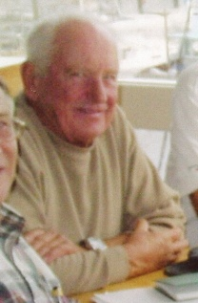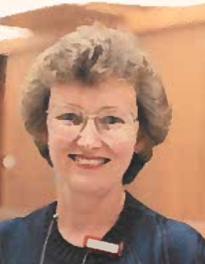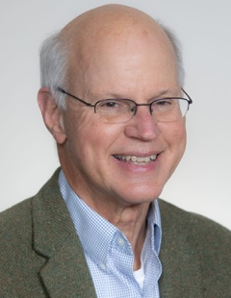
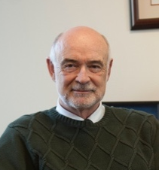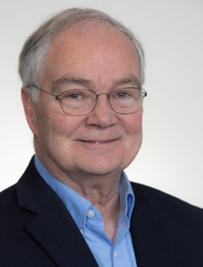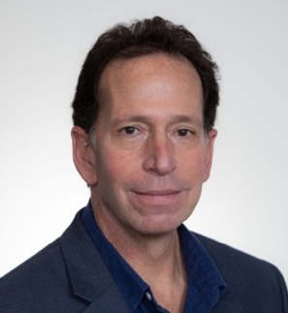
MCB Department Heads (l to r): Stuart Heywood 1987-1992, Judith Kelly 1992-1997, Philip Yeagle 1997-2007, David Benson 2007-2012, Michael Lynes 2012-2022, Carolyn Teschke 2022-2025, Adam Zweifach 2025-?

In 2011, Ken Noll published an essay in MCB Expressions – “Why is there no Biology Department at UConn?” It outlined the history of biology at UConn from the 19th century to around the founding of MCB in 1985. Here the focus is on the history of MCB from its immediate ancestors in the 1960s to around the Covid pandemic.
In many ways, the 1960s set the stage for the emergence of MCB. Then, most US universities, including UConn, expanded buildings, student populations and faculties in science and engineering. This expansion was a Cold War response to the sense that the US trailed the Soviet Union in science education, made real by the launch of Sputnik-1 in October, 1957. That event yielded, in rapid succession, the Defense Advanced Research Projects Agency (DARPA) in February, 1958, NASA in July and, by September, the National Defense Education Act (NDEA) for upgrading science, mathematics and associated facilities in higher education. Funding from NIH and NSF tripled in the next year and continued up from there. So, good times were rolling for science teaching and research.
Faculty profile 1960-1985
In 1961, UConn responded with the Life Sciences Building (renamed Torrey Life Sciences, TLS, in 1979) for housing biology faculty members, of which there were 20, with new hiring proceeding slowly. The building was constructed rather quickly, and has the distinction of escaping demolition more often than any other on campus, despite the occasional fire or flood. But it did and does provide useful space for biological sciences.

Reorganization 1 - BSG
In 1966, 41 CLAS biology faculty members were in four ‘organismal’ departments: Bacteriology (6 faculty members), Botany (8), Genetics (2) and Zoology & Entomology (25). Each department except Genetics offered eponymous BS degrees. Graduate degrees were offered in five Fields of Study: Bacteriology (7 faculty members), Biochemistry (8), Botany (7), Genetics (5), and the largest – Zoology & Entomology (24). Graduate faculty members included those from CLAS biology and ten others drawn from other departments.
In 1967, the four departments were reorganized into five sections that were more ‘molecular’ in a new Biological Sciences Group (BSG): Biochemistry & Biophysics (8 faculty members), Genetics & Cell Biology (9), Microbiology (5), Regulatory & Developmental Biology (10) and Systematic & Environmental Biology (20). In 1972, Ecology was added and Systematics & Environmental Biology changed to Systematics & Evolution. Administratively, the BSG had an Executive Director, and each Section had a Head, roughly equivalent to a department head, reporting to the Executive Director.
In 1968, a seven-story Annex to Life Sciences, with actual air conditioning, unlike Torrey, opened behind Life Sciences, and housed faculty members with a molecular bent.
With the new buildings, BSG faculty numbers grew to about 65 by 1970 spawning a large gaggle of Assistant Professors (Fig. 1). The Annex was built rapidly, leaned a bit, and was eventually demolished in 2003 when Biology Physics (BPB) was built.
Remarkably, graduate Fields of Study went from the five in 1967-68 to eleven in 1968-69: Bacteriology, Biochemistry, Botany, Cytology, Developmental Biology, Entomology, Genetics, Invertebrate Zoology, Parasitology, Physiology, and Vertebrate Zoology. Many of these changed, split, or even disappeared, up until the next reorganization in 1985 (traced in Fig. 3).
The proliferation of graduate programs in the late 60s and early 70s occurred amidst large scale cultural and scientific ferment. UConn students participated in a national student strike in 1970 to protest the Vietnam War (see https://archives.lib.uconn.edu/node/3291339 for a feel of the times), and BSG faculty members surfed the ruffled political landscape, with some interesting stories that best remain untold.
Oddly, campus unrest occurred amidst a massive increase in federal funding to universities. Biology was accelerating away from the descriptive to mechanistic, that is, molecular, approaches that came with the decoding of RNA in the early 1960s and other advances. In 1973-74, the organismal undergraduate majors of botany, microbiology (changed from Bacteriology in 1969) and zoology, became just two – General Biology, and a new one, Biophysics. This move reflected the tacit acceptance that biology disciplines were becoming more united at a fundamental level.

1985 - Reorganization 2 – MCB
From 1969 to 1985, the BSG stabilized at around 65-70 faculty members, with physical space limiting further expansion; some faculty members wound up being housed in Beach Hall, (a disjunct continued until the Engineering Science Building was occupied in 2018). In 1985, each of the seven sections (above) had about 10 faculty members depending on retirements, tenure decisions, and the occasional demise.
In 1984/85, graduate Fields of Study largely paralleled section names – Biochemistry, Biophysics, Botany, Cell Biology, Ecology, Entomology, Genetics, Microbiology, and Physiology & Zoology. This partitioning made sense as each Field of Study, and Section, harmonized with its national culture. Why then were the sections re-formed into MCB, EEB and PNB in late 1985? Two themes emerged in memos that flew through the Group around 1982.
First, approaches to biological sciences had changed. New molecular techniques and insights arose during the 70s and early 80s, famously the Boyer-Cohen DNA cloning in 1973, DNA sequencing and analysis by 1976-1977 and several other advances. The era of “molecular biology,” an old term coined by Warren Weaver at the Rockefeller Foundation in 1938, had finally blossomed. Plus, justified or not, ‘molecular biology’ just seemed more avant-garde than organismal biology.
In parallel, computing of the late ‘70s and early ‘80s moved the faculty from typewriters to Raytheon mainframe terminals, to personal computers (Apple II came out in 1977; IBM PC arrived in 1981; the 128K Mac arrived in 1984) that were providing new ways to acquire and analyze large data sets arriving from experimental systems. The transition was fast. Cool molecular and computational approaches could conceivably be applied to any biological problem under study.
The second reason driving the creation of new departments in 1985 was more, well, human. Seventy small businesses in seven sections wrapped in a single administrative unit, the BSG, bred discontent tinged with a bit of hauteur, vis a vis sibling Sections. Sections competed for faculty positions, equipment, space, TAs, essentially...money. Thus, a reorganization was viewed as alleviating some territorial issues, as well as bringing biology up-to-date at UConn, and possibly giving the Dean of CLAS, the referee, some peace.
Reorganization happened, by faculty vote, on July 1, 1985 after robust discussions by the entire BSG gathered in Room 154 in TLS. Discussions mainly revolved around “lumpers” and “splitters” – the lumpers wishing to combine like-minded sections, and the splitters wishing to spin off small departments from sections. In the end, the lumpers prevailed. Seven sections were rearranged to three Departments, with each faculty member choosing an affiliation.
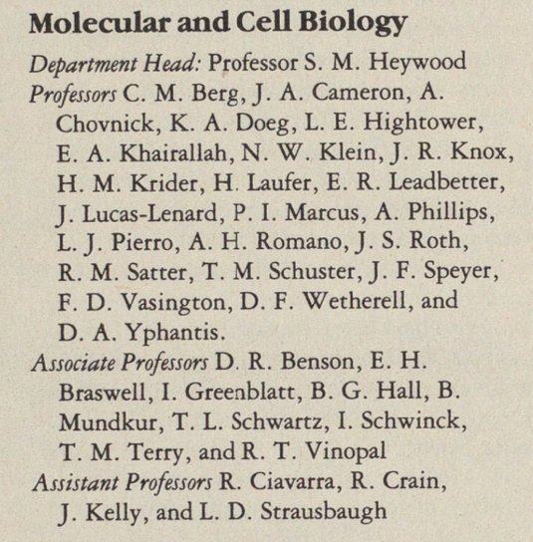
Agreeing on the name Molecular and Cell Biology was an entertaining exercise. Some assumed that their prior section name would be woven into the title of the new department. Others averred that MCB implied a too reductionist scope. Nonetheless, all worked with molecules at some level, and most worked with cells. So, Molecular and Cell Biology was accepted by a near-unanimous vote. The only remaining sticking point was whether Molecular and Cell Biology should be Molecular and Cellular Biology – an issue of whether one tolerates a noun masquerading as an adjective, or prefers a true adjective, to denote the Department. It was agreed that the (correct) dissident grammarians could use letterhead with the “cellular” option, which no one ever did.
Fig. 2. Faculty Roster from the 1986-87 catalog
After the dust settled, MCB had 37 tenured or tenure-track professors, including 31 men and six women. EEB had 25 members; PNB had 12. Faculty members from the previous Sections of Biochemistry and Biophysics, Genetics & Cell Biology, Microbiology, and one from Botany populated MCB. S Heywood was appointed to be the new MCB department Head, all in 1985.
The founding faculty of the new MCB was on the older side. Of 37 members, a high-water mark for the department, 24 were Professors, nine were Associate Professors but only four were Assistant Professors. At least 12 Professors were ex-military (Cameron, Klein, Heywood, Chovnick, Hightower, Marcus, Phillips, Romano, Roth, Vasington, Vinopal, and Wetherell) and three had escaped Europe ahead of WWII (Laufer, Speyer, Yphantis). MCB quickly earned the reputation of being quite a tough major.
The new undergraduate degrees were first offered in 1986-87, including MCB (BS), EEB (BA or BS) and PNB (BS), Biological Sciences (BA or BS), plus a BS in Biophysics through MCB. Graduate Fields of Study offered by MCB remained aligned with the old Sections - Biochemistry, Biophysics, Cell Biology, Genetics, and Microbiology. EEB retained the Fields of Study Botany, Ecology, Entomology and Zoology, and PNB retained Physiology and added Neurobiology. The Departments jointly offered general biology courses and advised Biological Sciences majors. The reorganization has stood the test of time for over 40 years with but a few issues.
One issue that emerged in the 1980s is that tenure/tenure-track MCB faculty numbers diminished, from 37 to about 26 in 2005 and currently 29, even with undergraduate enrollment at 21,000 today, up from 12,320 in 1985. Untimely deaths, retirements and tenure decisions coupled with budget constraints ratcheted down tenure track faculty number over time leaving some Fields of Study with five or fewer research active members. So, a negative feedback loop was created where positions were difficult to justify for an apparently small graduate Field of Study, especially if undergraduate courses were being ‘handled.’
A way to address the issue was to merge Fields of Study to amplify the voice of MCB. So, in 2011 the five Fields of Study merged into one, MCB. MCB first appeared as a Field of Study in 2013-2014. EEB and PNB had each done the same in 2009-2010. For MCB, previous Fields of Study became Areas of Concentration, and a commitment was made, so far, to retain their academic identity.
Along with creating one large Field of Study, an added benefit of merging was harmonizing graduate student treatment. The reorganization of 1985 had left different FOSs with different general exam formats. With a single Field of Study and common standards, graduate students could be treated more equitably in admissions, lab rotations, general exams, funding and some coursework.

What Else?
History is easier to discover if records exist. Unfortunately, historical records are hard to find for the many dozens of things that MCB has created: colloquia, conferences, facilities, centers, community outreach efforts, national awards, journals, Honors events, undergraduate research, summer programs, graduate mentoring, review panels etc. that MCB faculty members have initiated or been involved with over the past 40+ years of MCB’s existence. Specific things in the vein of an Extremophile conference, the North East Structure Symposium (NESS), the Center for Microbial Systems, Ecology, and Evolution annual meetings, ASM Future Leaders Mentorship Fellowship Program, Cell Stress and Chaperones and J Interferon Research journals, and so on, would never have happened without the willingness of MCB faculty members but generally have left little imprint.
To take the single category of facilities and centers that have become essential for research, MCB seems to have an organic capacity to create them as dictated by research and teaching needs. This capacity goes back to 1958, when several Biology professors of a molecular bent created the Institute of Cellular Biology, (later Institute of Cellular and Molecular Biology), probably with an eye to Sputnik-1, but also to F Crick’s famous “central dogma speech” in 1957. The Institute hosted conferences and seminars, and published the “Bulletin of the Institute of Cellular Biology” with current research from members. Activities faded in the 1990s, and it was last listed in the 1999-2000 Bulletin.
After MCB was born in 1985, facilities/centers proliferated. In 1986, the Biotechnology Center (later the Biotechnology/Bioservices Center, and now COR²E) was founded by MCB faculty members. The Center established biotechnology on campus, provided an umbrella for new technologies, and created a portal to collaborate with biotechnology start-ups. It was headed by T Schuster until 1990, P Marcus until 1995, T Chen to 2002, then Marcus again until 2011. The catalyst for its creation was the “biotech boom” heralded by the IPO of Genetech in 1980.
The physical Biotechnology Center, built in 1990, was a one-story building behind the Torrey Annex. Initially, it contained the “Macromolecular Characterization Facility” for DNA sequencing and analysis and protein purification and characterization, and the Analytical Ultracentrifugation Facility. The latter was enabled by an NSF Center grant awarded in 1988 to T Schuster, D Yphantis, E Braswell and J Philo. A Fermentation and Separation Facility (1988-2009, R Vinopal) was housed in the United Technologies Engineering Building.

The Center building was torn down in 2003, along with the Torrey Annex, to make way for the new Pharmacy Building, completed in 2005. The Center’s facilities moved to the new Biology/Physics Building (BPB) completed in 2003. By 2007, the Biotechnology Center umbrella had added the Animal Cell Culture Facility (1972-2017, M Sekellik and P Marcus), the Flow Cytometry and Confocal Microscopy facilities, and the Bioinformatics Facility.

D Knecht and J Covault (PNB) began the Confocal Microscopy Facility in 1990 with a grant from NIH. D Knecht’s research space in the Annex housed the first microscope, where he trained others to use it. Also in the late 80s, early 90s, M Lynes began the flow cytometry facility. He and L Silbart (Animal Sciences) were the first co-directors. Lynes, Silbart and Knecht then worked with T Chen, then Director of the Biotechnology Center, to combine the Flow Cytometry and Confocal Microscopy facilities within the Center around 2001. The descendants of the original facilities are the Advanced Light Microscopy Facility, and the Flow Cytometer Facility, both now part of the COR²E.

The Bioinformatics Facility was created as part of the Biotechnology/Bioservices Center in 2003 by J P Gogarten and P Lewis (EEB). Financial support for the facility was from intramural sources and the service was free to students and faculty to the chagrin of some administrators. In 2013 the facility was moved to the ISG and renamed the Computational Biology Core.
The Center for Applied Genome Technology (CAGT) was created in 2002 primarily by L Strausbaugh and housed in Beach Hall. It brought large scale Next-Gen DNA sequencing to Storrs via the 454 pyrosequencer purchased with NSF, DOJ, and internal monies. It was reestablished in 2014 as the Center for Genome Innovation (CGI) within the Institute for Systems Genomics (ISG) under the guidance of R O’Neill. The ISG itself had been established in 2012 to broaden the scope of genomics research to all branches of UConn.
The Microbial Analysis Resources and Services (MARS) facility was founded in 2014 by J Graf who tracked down funds to purchase a MiSeq machine and associated equipment for sequencing small genomes and for microbial population studies using 16S rDNA sequencing. It became part of the COR²E in 2016.
The Biophysics Facility was added in 2019 by faculty members in the Biophysics program. It includes microcalorimetry, microscale thermophoresis and protein X-ray crystallography. It is also affiliated with the Analytical Ultracentrifugation facility. The NMR Facility was established in 2004 with an NSF grant to A Albert with A Alexandrescu as facility Head. Both are part of the COR²E at present.
All exist to this day in some form, except for the Fermentation and the Animal Cell Culture facility that were discontinued due to disuse. The point to be made is that many facilities were begun by individuals primarily, but not solely, from MCB who needed them but who also insisted that they be generally available to the University community.
Formal academic programs were sometimes attached to facilities. In 1985, R Vinopal, D Benson and C Berg created the interdisciplinary Biotechnology Plan B MS Program designed for students keen on entering biotechnology. R Vinopal ran the program for 20 years from 1988 through 2008-09 using the Biotechnology Center resources for training. It eventually folded as it became redundant with other MS programs.
The Biotechnology MS program is the ancestor of the successful Professional Science Masters (PSM) programs that were initiated by L Strausbaugh. PSM programs succeeded as they received tuition support for lab courses, personnel, and equipment as an incentive. Applied Genomics was introduced in 2004, Microbial Systems Analysis (created by K Noll and run initially by E Leadbetter) was added in 2005 and Applied Biochemistry and Cell Biology (V Robinson, A Zweifach) was added in 2017. Other departments followed the model with their own PSM offerings.
So, given the history of MCB, both written and unwritten, the future of MCB will be determined both by academic tradition and also by the efforts of individual faculty members who create something new and broadly useful. As Ken Noll wrote in 2005: “The history of the organization of biological sciences at UConn and its predecessors reflects not so much the parochial interests of its faculty and students, but the origin of each discipline and the dynamism of their sciences.”

Time line for Department, Fields of Study and UG Major names.
Yellow: MCB related; Green: EEB related; Blue: PNB related; Pink: General Biology

