How should we manage the introductory course sequence (e.g. 1107) and are there changes that should be made to the content of the laboratories or lectures?

Would offering more than one intro bio option better serve our students?
- Now that we have another APIR at Storrs, should we offer another variation of intro bio?
  - This could create the space to go deeper on some topics and make the breadth of the course more manageable
- BIOL 1107 is the only option for intro bio other than EEB’s 1102.
- Currently the course is divided into 2 parts

Part I – molecular and cellular biology
    - Basic biochemistry concepts – atomic structure, electronegativity, polarity, chemical bonds – 2 classes
    - Macromolecules - 4 classes
    - Membranes – 1 class
    - Thermodynamics – 1 class
    - Cellular respiration – 2 classes
    - DNA replication – 2 classes
    - DNA transcription and translation – 3 classes
    - Cell communication – 2 classes
    - DNA technology – 1 class
    - Genomics and proteomics – 1 class
    - Regulation of gene expression – 2 classes
    - Mendelian genetics – 2 classes

Part II – animal physiology
- Multicellularity – 1 class
- Thermoregulation – 1 class
- Digestive System – 2 classes
- Gas exchange – 2 classes
- Circulatory system – 1 class
- Homeostasis - 1 class
- Excretory system – 1 class
- Nervous system – 2 classes
- Musculoskeletal system – 1 class
- Endocrine system – 1 class
- Animal reproduction – 1 class
- Immune system - 2 classes

Lab Exercises
- Lab basics – conversions, using balances, micro-pipets and serological pipettes, creating solutions
2. Chromatography and spectrophotometry – understanding independent and dependent variables, data visualization, amino acid structure
3. Microscopes
4. Tonicity, osmosis, semi-permeable membranes
5. Mitochondrial enzyme activity (oxidation and reduction)
6. Understanding and analyzing karyotypes
7. Genomic DNA isolation from E. coli and PCR
8. Agarose gel electrophoresis
9. beta-galactosidase activity assay
10. Creating transcripts and reading a codon chart
11. Intro to bioinformatics
12. Histology
13. Dissections – fetal pig1-3 body systems/week

What needs to be graded from these exercises (automatically or by a TA)?
Currently: quizzes, in-class assignments, 2 lab reports, 2 practical exams
Could exercises be better aligned with lecture component of the course? Or more research-oriented and less related to conveying course content?

- BIOL 1107 is a prerequisite for many student academic programs
- Medical and dental schools
- Specific majors -
  - Biological Sciences
  - Molecular and Cell Biology
  - Ecology and Evolutionary Biology
  - Physiology and Neurobiology
  - Structural Biology and Biophysics
  - Allied Health (1107 recommended over 1108; one is required)
  - Animal Science
  - Biomedical Engineering
  - Diagnostic Genetic Sciences
  - Dietetics
  - Kinesiology Programs
  - Athletic training
  - Exercise Science
  - Strength & Conditioning
  - Marine Sciences
  - Medical Laboratory Sciences
  - Nursing
  - Nutritional Sciences
  - Pathobiology
  - prePharmacy
  - Science Education
Part II – animal physiology
- Multicellularity – 1 class
- Thermoregulation – 1 class
- Digestive System – 2 classes
- Gas exchange – 2 classes
- Circulatory system – 1 class
- Homeostasis - 1 class
- Excretory system – 1 class
- Nervous system – 2 classes
- Musculoskeletal system – 1 class
- Endocrine system – 1 class
- Animal reproduction – 1 class
- Immune system - 2 classes
- These majors don’t require BIOL 1107, but BIOL 1107 is one of three (BIOL 1108 or 1110) course options to fulfill a general education requirement.
  - Agriculture and Natural Resources
  - Chemical Engineering (BIOL 1107 is among options for science electives)
  - Chemistry
  - Civil Engineering (BIOL 1107 is among options for science electives)
  - Cognitive Science
  - Computer Engineering (BIOL 1107 is among options for science electives)
  - Computer Science
  - Engineering Physics
  - Environmental Science
  - Geography
  - Geoscience
  - Math
    - Math-Stats
    - Math-Actuarial Science
    - Math-Physics
  - Natural Resources
  - Physics
  - Psychology (BIOL 1107 suggested)
  - Turfgrass and Soil Science - Soil Science concentration
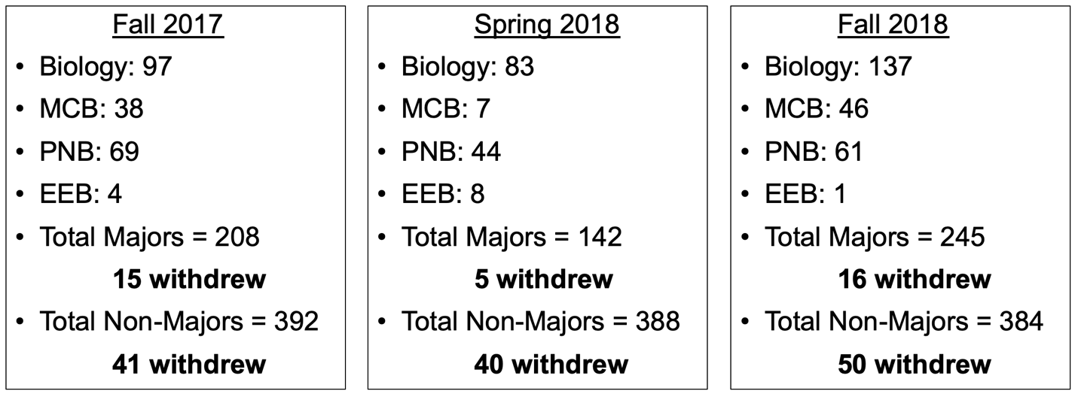

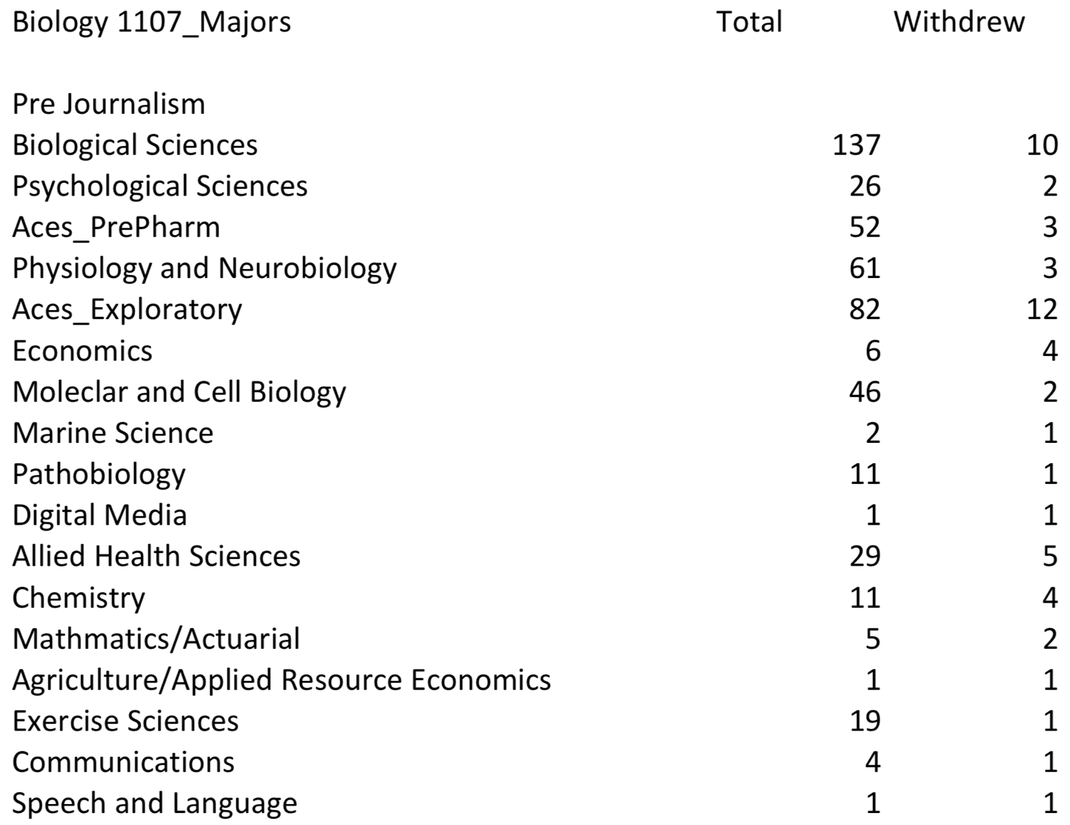

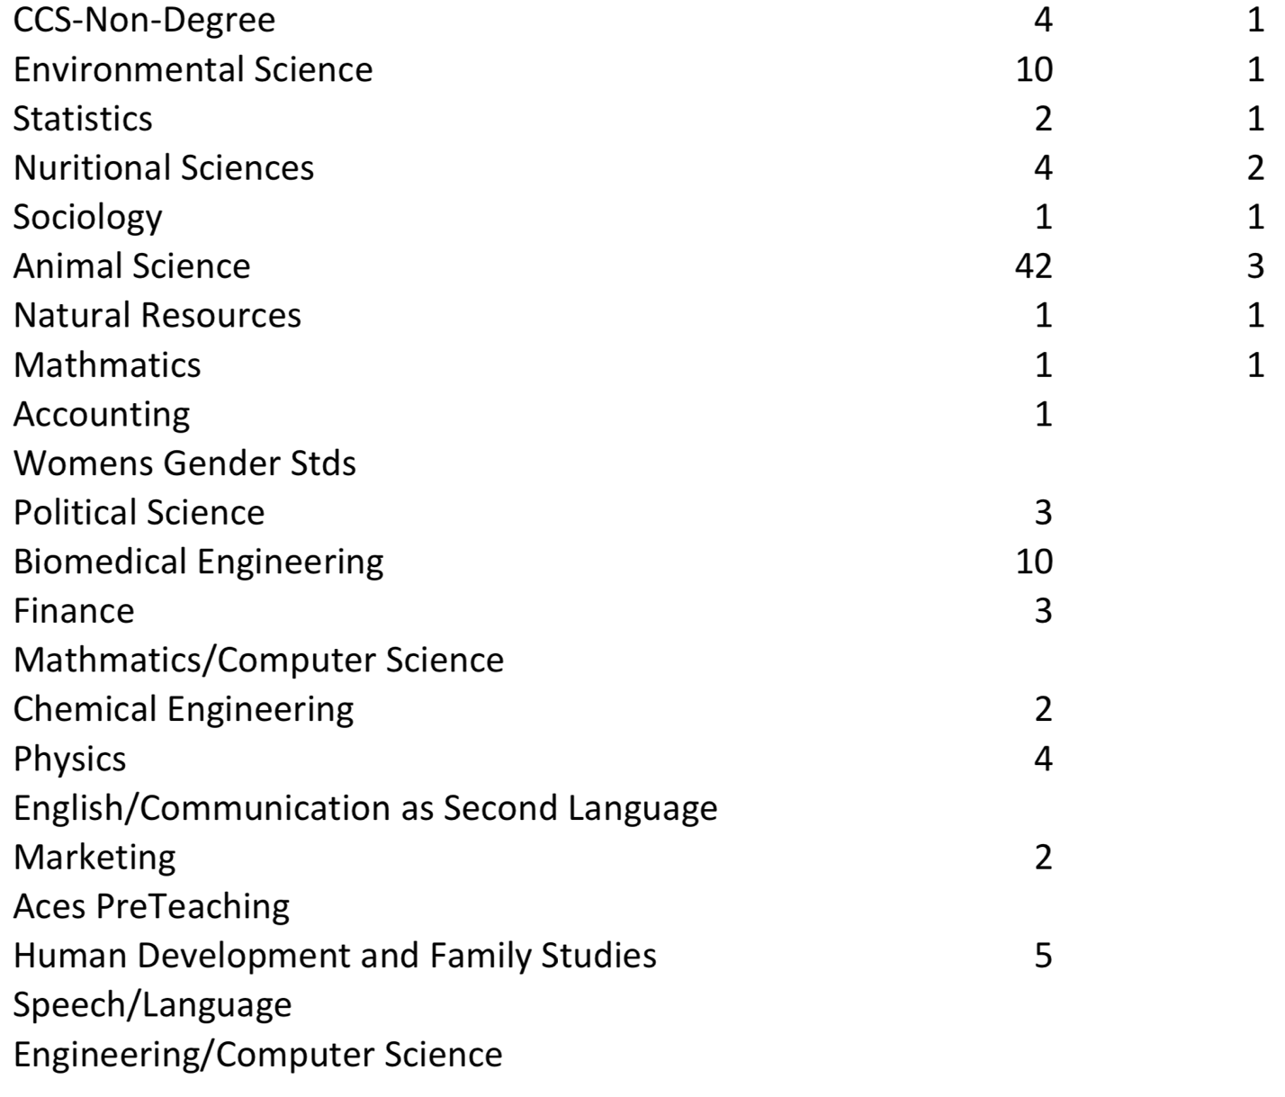

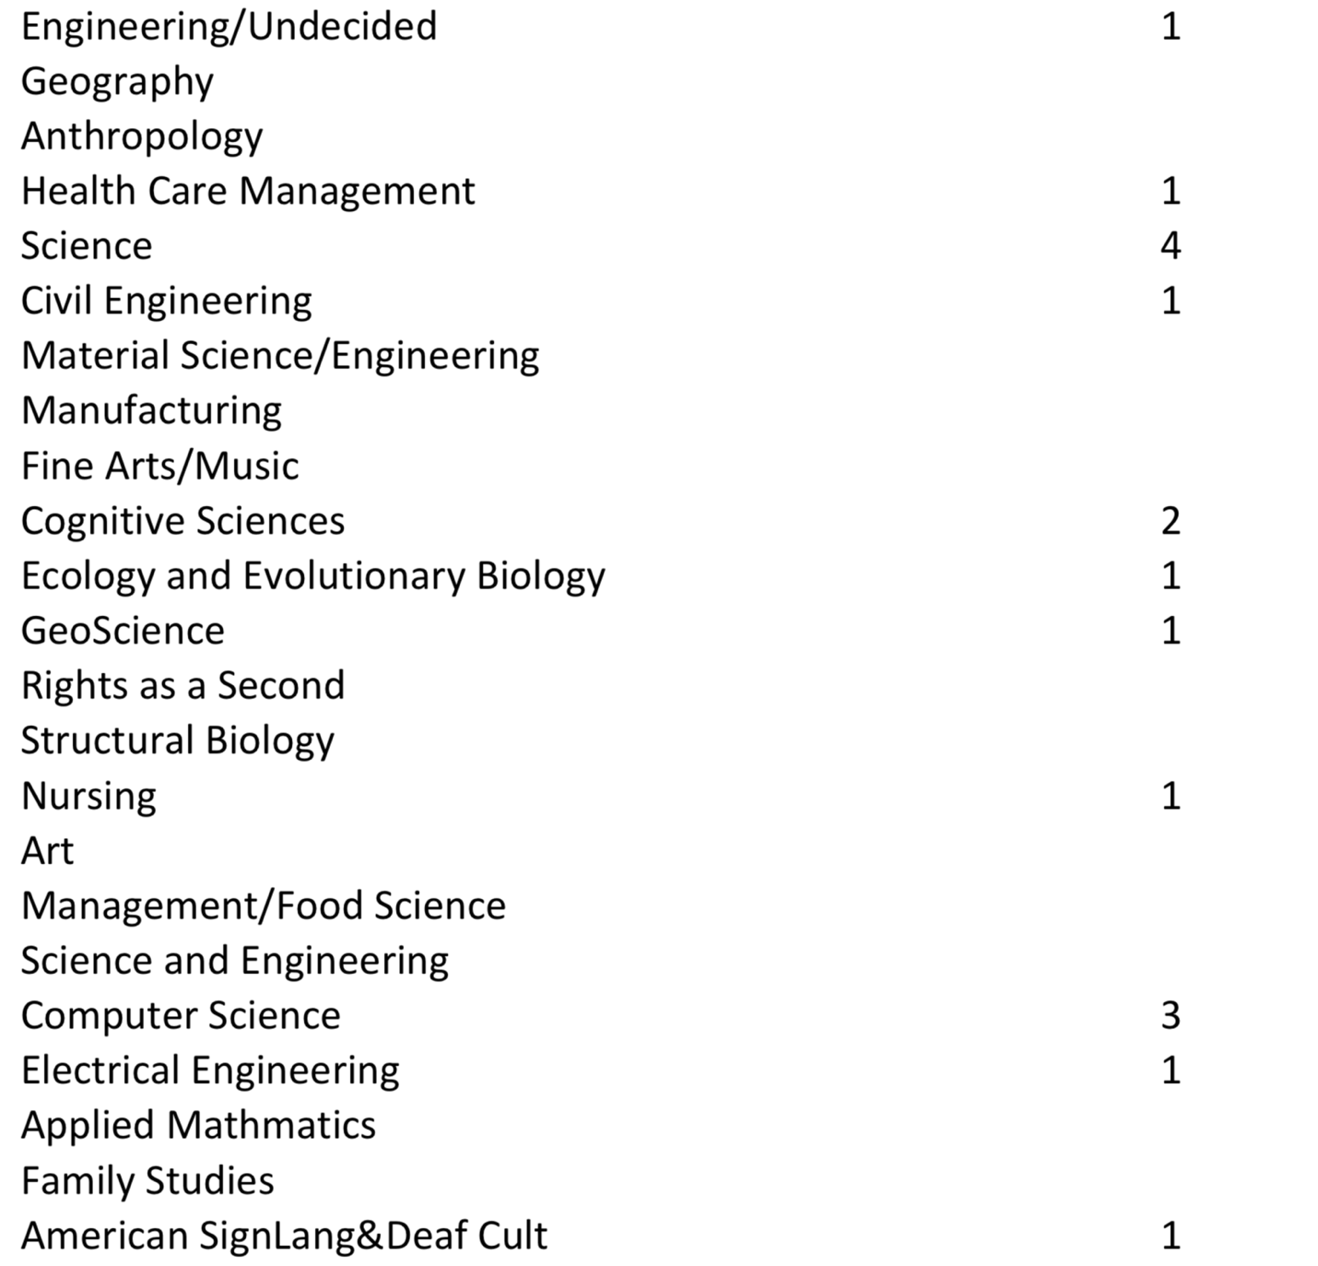

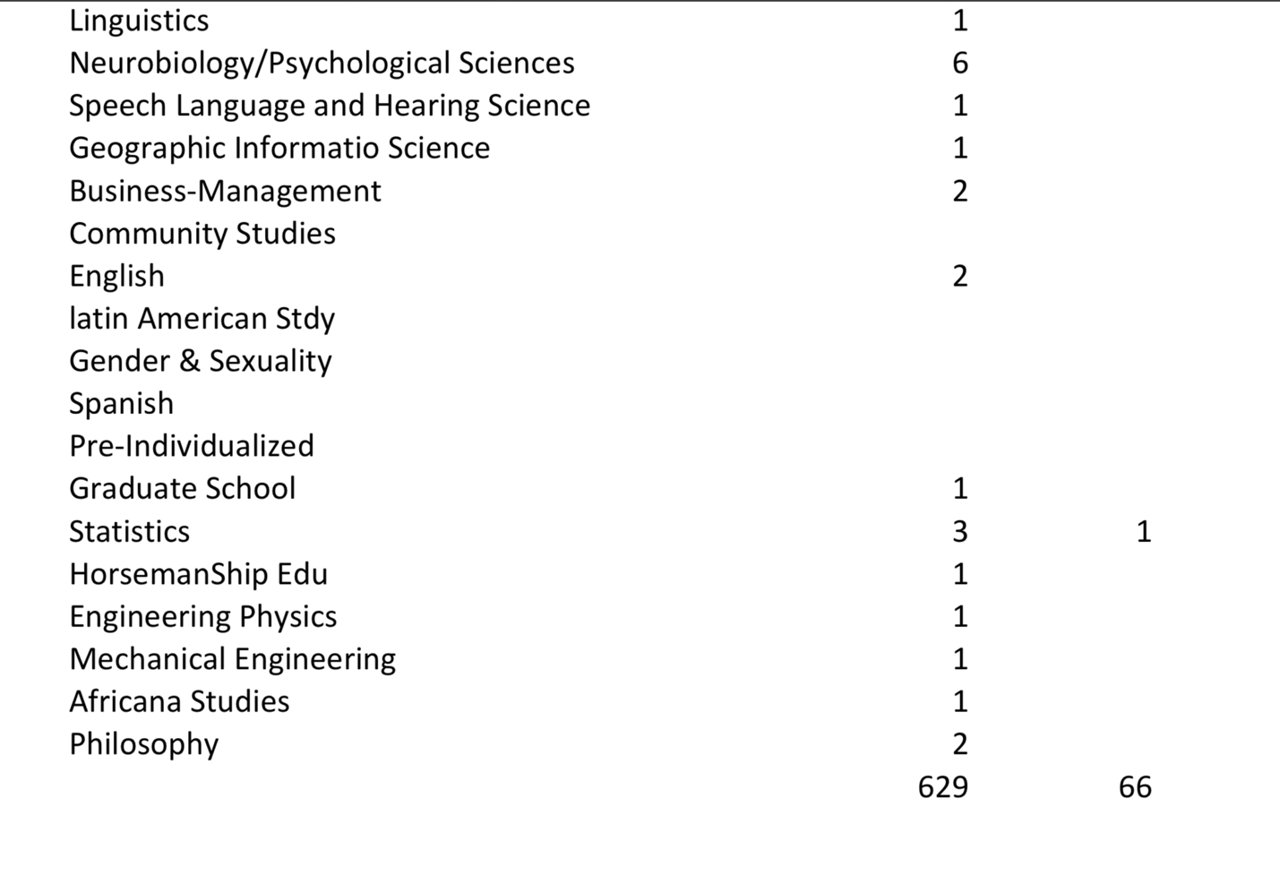

- If we wanted to offer a new form for intro bio, what could that look like? There are several possibilities. Here are 2.

- An updated BIOL 1107 (Tom)
Molecular biology focus
Expand on animal development, mitosis/meiosis, genetic engineering, biotechnology
Spend less time on body systems – choose ~2
Introduce weekly collaborative problem-solving in-class exercises.
MCB (and any other major) can continue to require this course.

- A new course (Elizabeth)
Module-based course that approaches molecular, cellular, and systems biology through human organ systems
Organize the course bigsmall: Explicitly connect molecular and cell biology concepts to the whole organism using human health and disease as the examples to contextualize basic biology
Examples from Dylan: to discuss diffusion and osmosis, frame this around nephrons and the kidney. Energy and energetics mitochondrial deficiency diseases
Could organize the course around 3 units that address basic bio questions:
  - Basic Needs – what processes are necessary for living things?
  - Inheritance – how does DNA work?
  - Communication and Control – how do the cells of the body work together?
What would this new course do for (some) students that existing 1107 can’t?
  - Engage them based on motivating interests related to future employment
  - Contextualize the parts of biology a freshman is least likely to be familiar with (molecular bio) – manage feelings of overwhelm
  - Improves the flow of the semester – integration of levels of biology
Possible texts – Biology for Health https://www.amazon.com/Biology-Health-Applying-Activities-Living/dp/1403945470; OpenStax Biology 2e + an anatomy and physiology text?

Any major could adopt this course as an acceptable pre-requisite. The goal will be to create a course equivalent to BIOL 1107 with a different focus and structure.

